 **Documentation**

***Of***

**E-PROJECT**



Aknowledgement.

We are thankful to almighty, ALLAH with his grace and mercy we have been successfully. We hereby presenting project **‘HTML /CSS / Java Script’** in your hands. We have tried our best to take all relevant and important topics in consideration so that this project may become more effective.

This is our **FIRST SEMESTER CPISM** project. We have tried our best & struggled for a better outlook to come. This project has been developed with the help of **‘HTML /CSS’** our assignment was to make a Website for **“BagBag”** as a project and we have used **‘Visual Studio Code’** for coding.

We earnestly hope that this project will provide all the necessary information required for the user to fulfill their requirement. However, suggestions for improvement of the project will be thankfully acknowledge.

THANK YOU.

Introduction

The Thirst of learning, up grading technical skills and applying the concepts in real life environment at a fast pace is what the industry demands from IT professionals Today. However busy work schedules, far-flung locations, unavailability of convenient time-slots pose as major barriers when it comes to applying the concepts into realism and hence the need to look out for alternative means of implementation in the form of laddered approach.

The above truly pose as constraints especially for our students too! With their busy schedules, it is indeed difficult for our students to keep up with the genuine and constant need for integrated application which can be seen live especially so in the field of **IT** education where technology can change on the spur of a moment. Well, technology does come to our rescue at such times!!

Keeping the above in mind and in tune with our constant Endeavour to use Technology in our training model, we at **APTECH** have thought of revolutionizing the way our students learn and implement the concepts using tools themselves by providing a live and synchronous **“CPSIM – eProject”** learning environment!

Requirement Specifications

The Web site is to be created based on the following requirements.

1) The Home Page should be created making use of Sections with a suitable

logo, the header section can be added which will show images of various

Bags.

2) The site must contain the links to navigate through various types of garments

3) Site should have different section for Men, Women and Kids should be

placed accordingly.

5) Specification and Pricing of garments should be added along with the images.

6) Website should provide section for various brands offered in the store.

7) Gallery section should be added for viewing different images.

8) Feedback must be allowed to enter by the viewer

9) Site map, Gallery, about us, Queries link, Contact us link must be added.

10) The advertise section with various facilities provided should be mentioned.

Requirements

**Hardware**

* A minimum computer system that will help you access all the tools in the courses is a Pentium 166 or better
* 64 Megabytes of RAM or better

**Software**

* Notepad/HTML editor
* Dreamweaver
* Visual Studio code
* IE 5.0/ Netscape 6.0

**Homepage**

  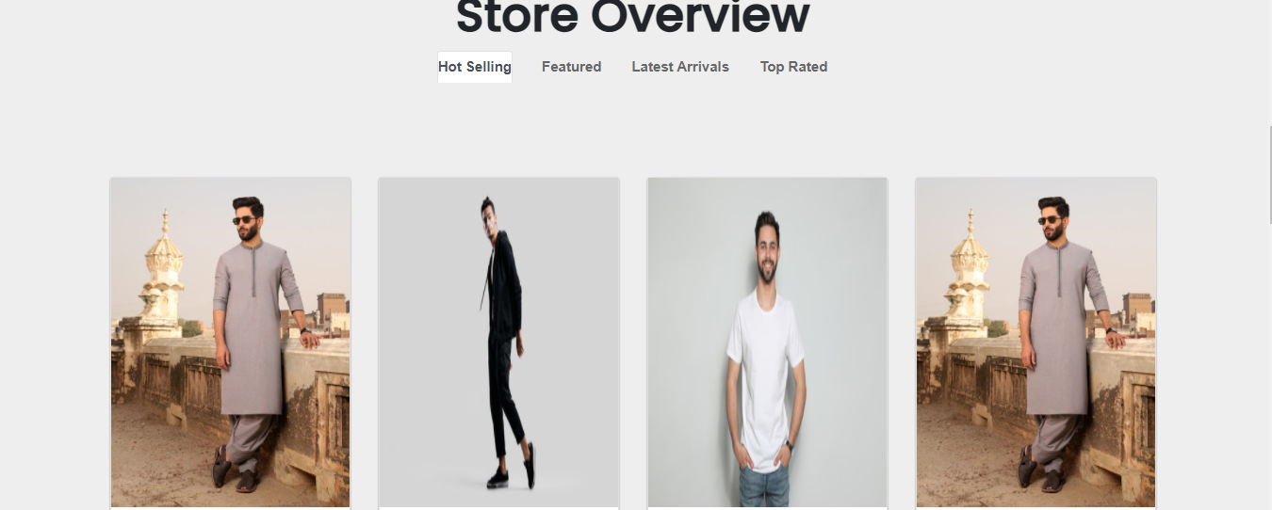 

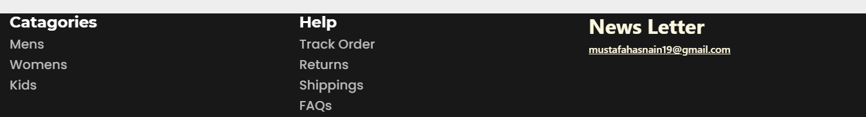

**Products Page**

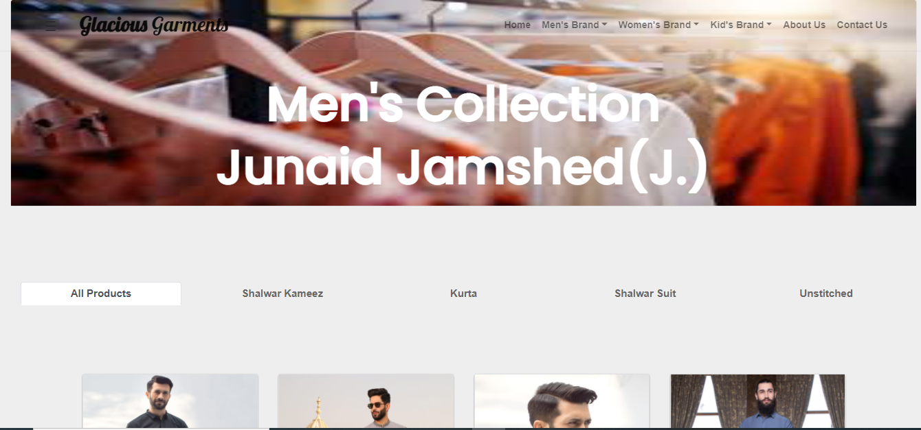

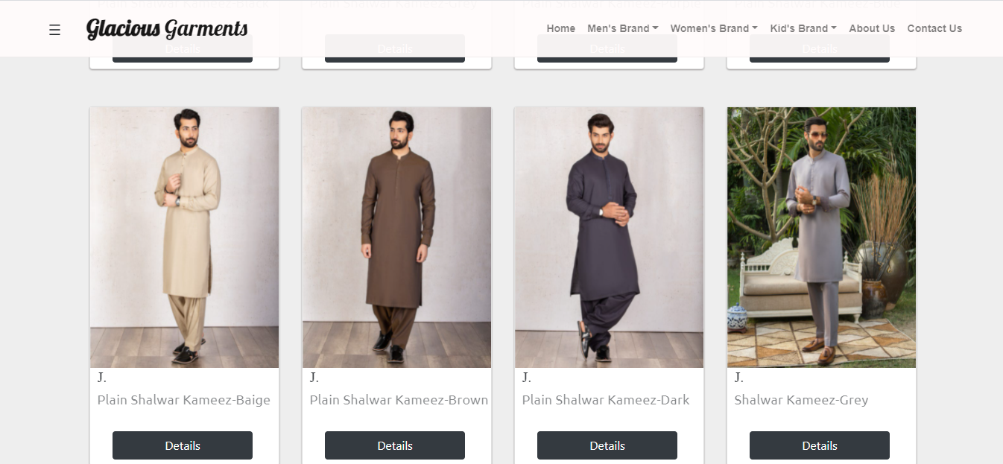

**Our Brands**



 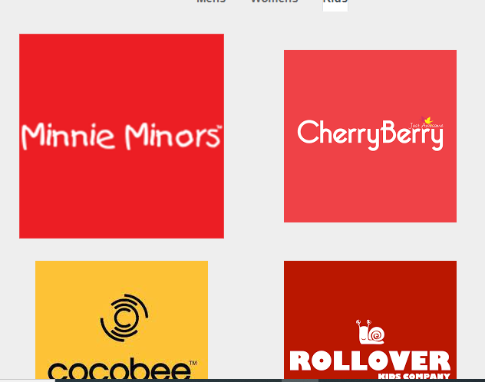

**Footer**

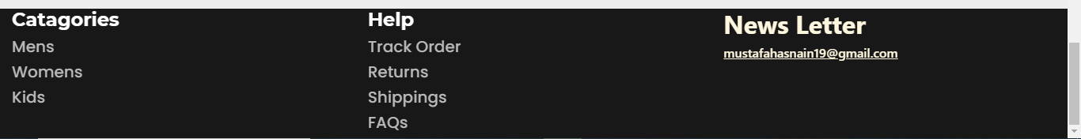

**MEN SECTION**

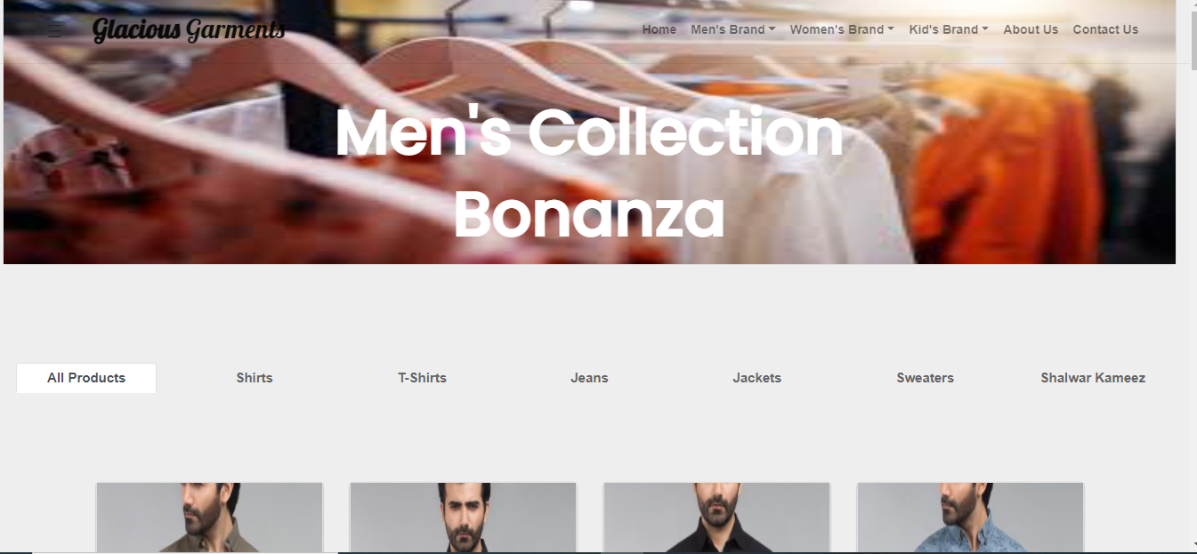

**WOMEN SECTION**

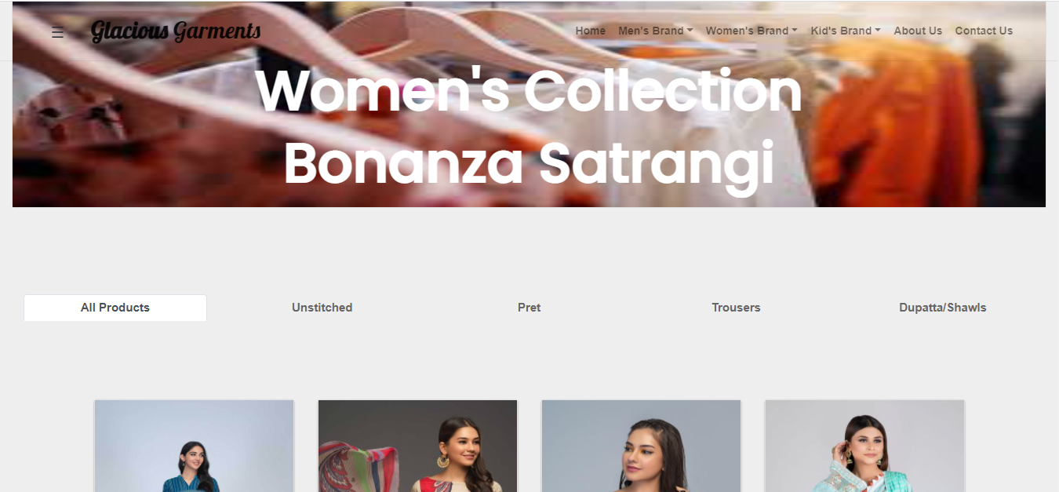

**KIDS SECTION**

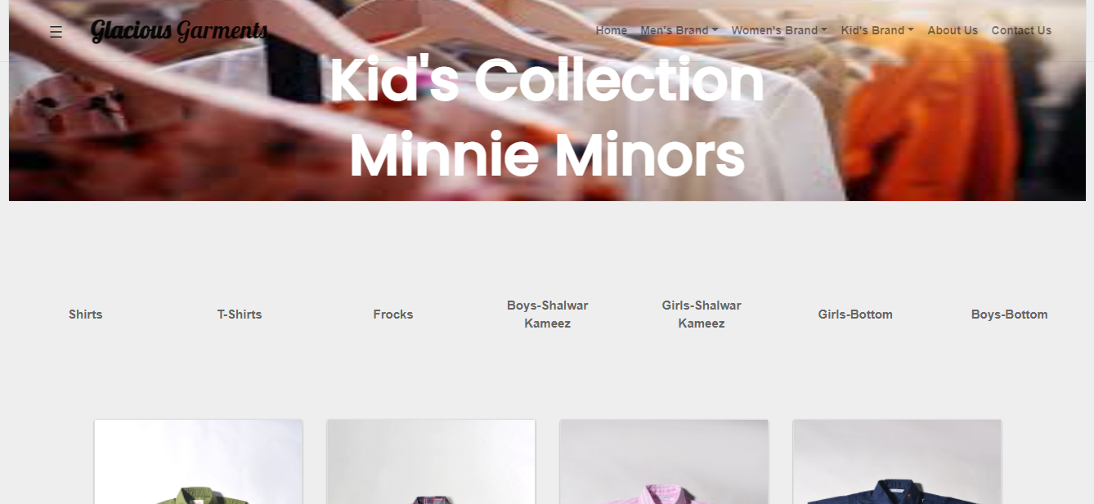

**ABOUT US**



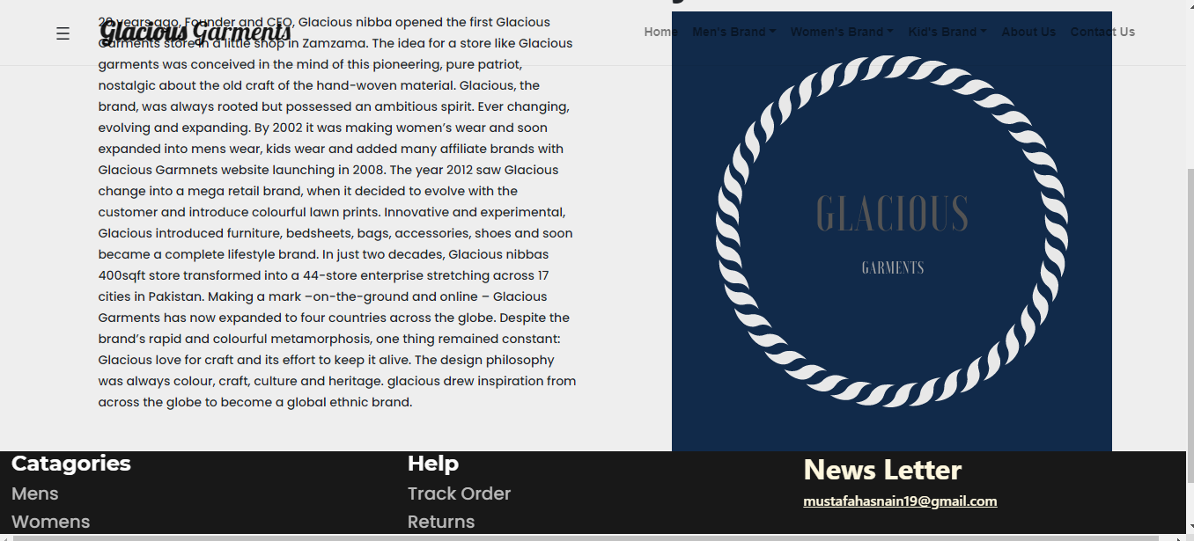

**PRODUCT DETAILS**

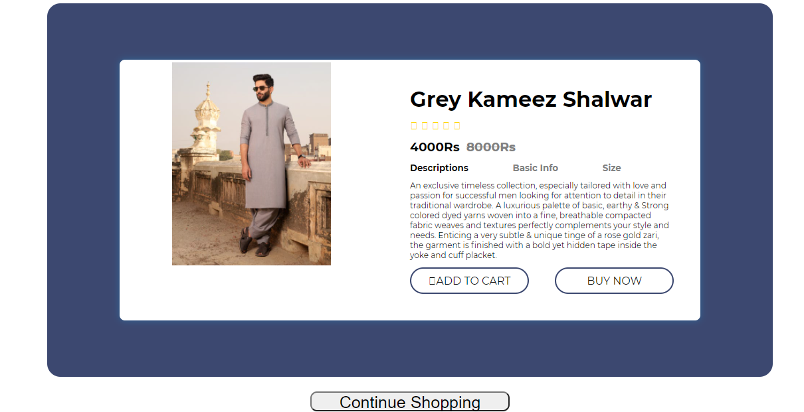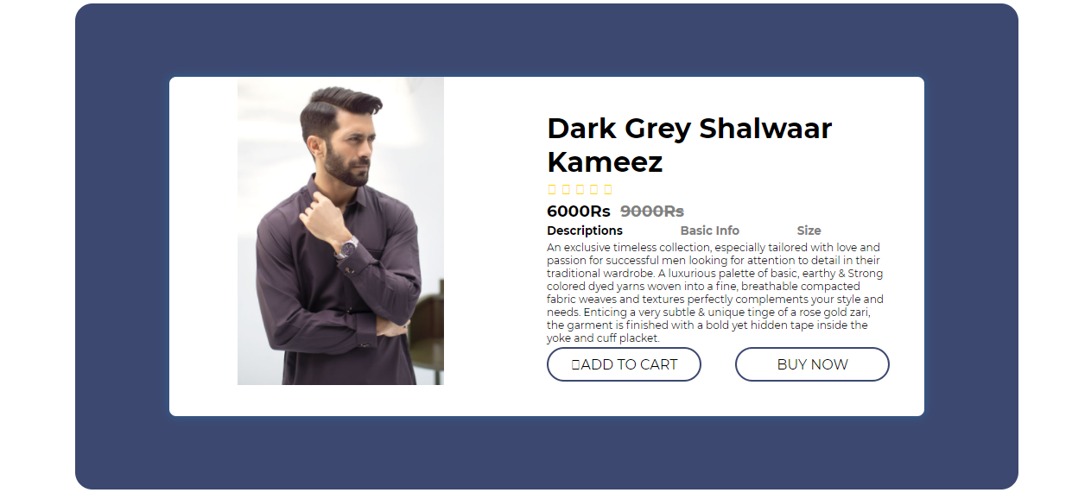

**Task Sheet**

|  |  |
| --- | --- |
| Student Name | Role |
| Mustafa Hasnain | Analysis, Coding & Documentation |
| Abdullah Wasim | Design of Detail Pages, About Us, Contact Us |

|  |  |
| --- | --- |
| Junaid Waris | Absent |
| Mustafa Rashid | Analysis |
| Sheikh Muhammad Sufiyan | Analysis |